Old UI Design
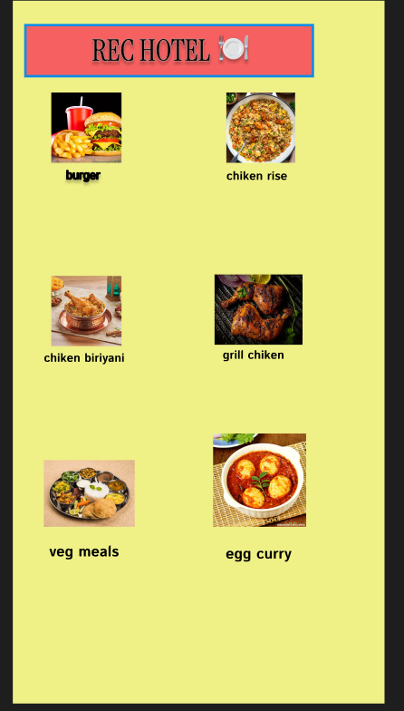
❌ Bad Design (Old UI)
- Flat & Dull UI – The background was plain and lacked personality.
- Poor Profile Picture Placement – The profile picture was small, used a rectangular frame, and looked outdated.
- Low Contrast & Readability Issues – The light purple background with white text resulted in low contrast, making the text hard to read.
- Poor Visual Hierarchy – The username and designation had the same size and color, so there was no clear distinction in importance.
- Unstructured Layout – Stats like Posts, Likes, and Following were not highlighted, making navigation difficult.
- Single Column Post Display – Posts were stacked one below another, creating a cluttered appearance.
Modified UI Design
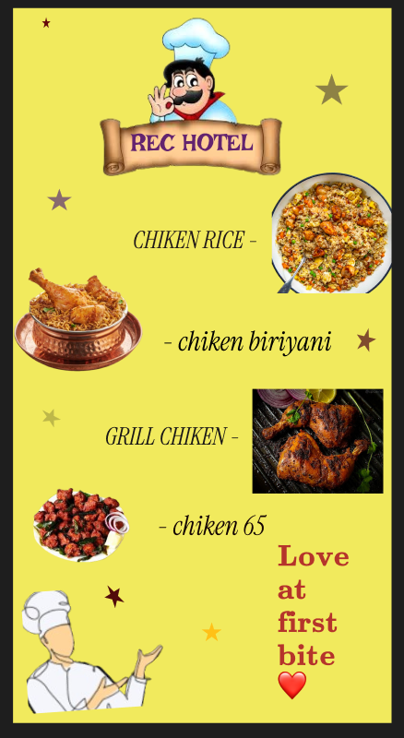
✅ Good Design (Modified UI)
• Header Background Image – A visually appealing background image is placed behind the profile, giving it an engaging look.
• Profile Picture Integration – The profile picture is circular, larger in size, and overlaps the header, creating a modern feel.
• Improved Layout & Typography – Proper spacing, centered alignment, and readable fonts are used.
• Color & Contrast – A white background with pink accents for buttons, and bold fonts for the username and stats improve visibility.
• Profile Stats Display – Posts, Followers, and Following are displayed prominently.
• Call to Action Buttons – Follow and Message buttons are larger and more attractive.
• Grid-Based Image Layout – Posts are arranged in a neat grid with a consistent aspect ratio.

